Referral Form – Young Adults Mentoring
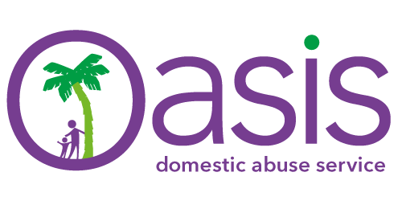
NB: As referrals contain sensitive personal data please password protect this form and email through. You will need to telephone through the password to the contact at the end of the form.
Eligibility criteria
- Young females aged between 16 and 25 years of age;
- who have experienced domestic abuse within their family home;
- are at risk of entering into abusive relationships in the future;
- and/ or are at risk currently within an abusive relationship

Please complete all three pages of the form
Date of Referral: |  |  | Referring agency:
Contact name: |  |  | Contact role:
Contact number: |  |  | Contact email:
Does client consent to referral?  Y / N |  |  | Is client at work/ school/college?: Y/N  Contact details:
Any other agencies working with client? Y / N
Agency contact details:

Name of client: |  |  | DOB: |  |  |  |  | Age:
Address: |  |  |  |  |  |  |  | Permission to write:  Y / N
Home phone number: |  |  |  | Permission to call:  Y / N |  |  |  | Permission to leave message:  Y / N
Mobile number: |  |  |  | Permission to call:  Y / N |  |  |  | Permission to leave message:  Y / N
Safe email address:

Is the person currently living in abusive/potentially abusive environment? |  |  |  | YES |  |  | NO
Have they previously lived in an abusive/potentially abusive environment? |  |  |  | YES |  |  | NO
Does the client have any children?  If yes please give details. |  |  |  | YES |  |  | NO
Reason for referral (Include any other details you feel are relevant. Use a separate sheet if necessary):

Ethnicity (please tick):
White British |  | African |  |  |  | Bangladeshi
White Irish |  | Caribbean |  |  |  | Pakistani
White/Black Caribbean |  | Indian |  |  |  | Chinese
White/Black African |  | White Asian |  |  |  | Black Other
Asian Other |  | Preferred not to say |  |  |  | Other mixed background
Sexual Orientation
Type/Don’t Know/Prefer not to say:

ABLE Risk Indicator

ATTITUDES AND FEELINGS
Significant low self-esteem |  | Lack of empathy
Angry feelings |  | Expressions of despair
Feels Shame/Guilt/Responsibility |  | Poor impulse control
Anxiety |  | Low motivation to change
Lack of remorse |  | Thought distortions
Suicidal thoughts/feelings |  | Recurrent physical symptoms
BEHAVIOURS
Communication difficulties |  | Poor or inappropriate interpersonal relationships
Concerning mobile phone/internet use |  | Substance misuse
Have you ever made allegations of assault or been accused of assaulting another |  | Former or current exclusions/truancy from school/college
Offending Behaviour |  | Have you ever had/do you currently have STI’s
Avoidant Behaviours |  | Lack of engagement
Eating Disorders |  | Risk taking
Self - Harm |  | Aggressive or Intimidating behaviour
Sleep Disturbances | Type:
LIFE EXPERIENCES
Emotional neglect in childhood |  | Family history MH issues
Physical Abuse |  | Family history of substance misuse
Sexual Abuse |  | Inappropriate accommodation
Family Breakdown |  | Isolated from peers/network
Family history of Domestic Abuse |  | Bereavement/significant loss
Learning Difficulties |  | Young carer

Please email your password protected form to cyp@oasisdaservice.org and telephone your password on 01843 269400 or send it in a separate email.

