Referral Form for Children and Young Peoples Mentoring Service

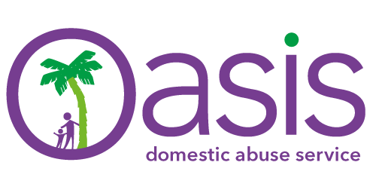
NB: As referrals contain sensitive personal data please password protect this form and email through. You will need to telephone through the password to the contact at the end of the form.
Please complete all three pages of the form
Criteria

Young males aged between 11 and 18 years of age;

- who have experienced domestic abuse within their family home;
- are at risk of entering into abusive relationships in the future;
- and/or are at current risk within an abusive relationship

N.B. This service may not be suitable for those meeting Tier 3 or above so please telephone to discuss prior to making the referral
Date of Referral: |  |  | Referring agency:
Contact name: |  |  | Contact role:
Contact number: |  |  | Contact email:
Does CYP consent to referral?  Y / N |  |  | Does parent/carer consent? Y / N  Is consent required? Y / N
Any other agencies working with client? Y / N  Agency contact details: |  |  | Is client at work/School/College:  Contact details:
Name of young person: |  |  | DOB: |  |  |  |  | Age:
Name of parent/carer: |  |  | DOB: |  |  |  |  | Age:
Address: |  |  |  |  |  |  |  | Permission to write:  Y / N
Home phone number: |  |  |  | Permission to call:  Y / N |  |  |  | Permission to leave message:  Y / N
Mobile number: |  |  |  | Permission to call:  Y / N |  |  |  | Permission to leave message:  Y / N
Safe email address:

Child/young person currently living in abusive/potentially abusive environment? |  |  |  | YES |  |  | NO
Child/young person previously living in abusive/potentially abusive environment? |  |  |  | YES |  |  | NO
Has a CAF been completed for the young person? |  |  |  | YES |  |  | NO
Does the young person have any children?  If yes please give details. |  |  |  | YES |  |  | NO
Reason for referral (Include any other details you feel are relevant. Use a separate sheet if necessary):

Ethnicity of young person (please tick):
White British |  | African |  |  |  | Bangladeshi
White Irish |  | Caribbean |  |  |  | Pakistani
White/Black Caribbean |  | Indian |  |  |  | Chinese
White/Black African |  | White Asian |  |  |  | Black Other
Asian Other |  | Preferred not to say |  |  |  | Other mixed background
Sexual Orientation
Type/Don’t Know/Prefer not to say:

ATTITUDES AND FEELINGS
Significant low self-esteem |  | Lack of empathy
Angry feelings |  | Expressions of despair
Feels Shame/Guilt/Responsibility |  | Poor impulse control
Anxiety |  | Low motivation to change
Lack of remorse |  | Thought distortions
Suicidal thoughts/feelings |  | Recurrent physical symptoms
BEHAVIOURS
Communication difficulties |  | Poor or inappropriate interpersonal relationships
Concerning mobile phone/internet use |  | Substance misuse
Have you ever made allegations of assault or been accused of assaulting another |  | Former or current exclusions/truancy from school/college
Offending Behaviour |  | Have you ever had/do you currently have STI’s
Avoidant Behaviours |  | Lack of engagement
Eating Disorders |  | Risk taking
Self - Harm |  | Aggressive or Intimidating behaviour
Sleep Disturbances | Type:
LIFE EXPERIENCES
Emotional neglect in childhood |  | Family history MH issues
Physical Abuse |  | Family history of substance misuse
Sexual Abuse |  | Inappropriate accommodation
Family Breakdown |  | Isolated from peers/network
Family history of Domestic Abuse |  | Bereavement/significant loss
Learning Difficulties |  | Young carer
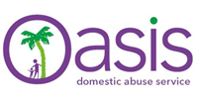
ABLE Risk Indicator

Please email your password protected form to cyp@oasisdaservice.org and telephone your password on 01843 269400.

